CHISHOLM CHALLENGE COMPETITION
Chisholm Challenge (CC) was on January 13th held just prior to the Fort Worth Stock Show and Rodeo for Therapeutic Riding Centers. We had 12 riders competing in Equitation and Trail classes. Everyone gave a good performance in all events. Our riders received many ribbons. For some of our team this was their first competition and they did great!
David Brown was competing for the first time winning his class events. Also, he brought home a belt buckle and ribbon for Reserve High Point Competitor.
Our Instructors and Volunteers did a fantastic job of insuring our riders were ready to compete at their scheduled time and place plus offering encouragement before the riders entered the arena for their event.
Our horses took good care of our riders and performed their best. They deserve our praise too!
The Board of Directors and Staff appreciate all the preparation done by volunteers, instructors, riders and parents. We all give a huge thank you to all who gave, time and effort to the CC competition.
Chisholm Challenge Pictures:
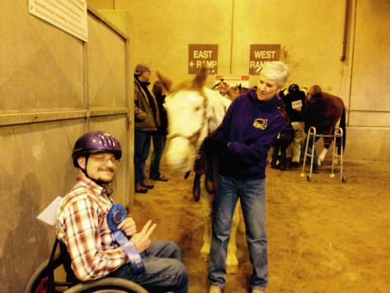
Which of the following has the best memory – Horse or Elephant ??
David Brown, Ariel & Claire Rock
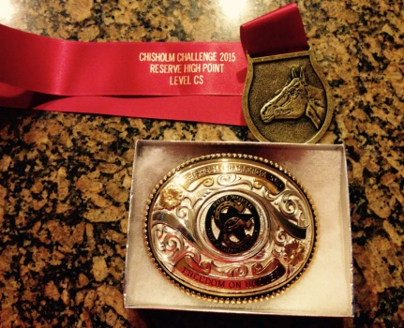
David’s Ribbon & Belt Buckle

VOLUNTEER TRAINING:
On February 21 a Volunteer Training session was held at the Ranch. We had 20 individuals attend this session. The training was conducted by Demi Prentiss and Pat Dellemann assisted by the Riding Unlimited Instructors.
Everyone learned how we need to have jobs performed so that our riders and volunteers are safe during classes.
The main “jobs” discussed were Sidewalkers and Horse Handlers. Both positions are very important because they function as a team insuring classes are safe and fun.
We are looking forward to having a good Spring Session. At this time the weather has been challenging, but eventually all classes will be held. Classes started Feb 25th.

UPCOMING EVENTS:
- March 8 – Daylight Savings Time Began.
- March 28 – Regional Special Olympics – Held at Born to Be in Aubrey
- This Fall (September) – A fund raising event will be held at the Ranch. If interested in helping prepare for the event contact the Riding Unlimited Office at 940-479-2016 and we will utilize your abilities. More details to come.

The Horse is believed to have a better memory than an elephant. The horse will remember you forever – so treat him or her well.

